**Design Patterns in Java**

A design patterns are **well-proved solution** for solving the specific problem/task.

### When should we use the design patterns?

We must use the design patterns **during the analysis and requirement phase of SDLC**(Software Development Life Cycle).

|  |  |  |
| --- | --- | --- |
| 1.Creational Design Pattern | 2. Structural Design Pattern | 3. Behavioral Design Pattern |
| 1. Factory Pattern 2. Abstract Factory Pattern 3. Singleton Pattern 4. Prototype Pattern 5. Builder Pattern | 1. Adapter Pattern 2. Bridge Pattern 3. Composite Pattern 4. Decorator Pattern 5. Facade Pattern 6. Flyweight Pattern 7. Proxy Pattern | 1. Chain Of Responsibility Pattern 2. Command Pattern 3. Interpreter Pattern 4. Iterator Pattern 5. Mediator Pattern 6. Memento Pattern 7. Observer Pattern 8. State Pattern 9. Strategy Pattern 10. Template Pattern 11. Visitor Pattern |

# How to prevent Singleton Pattern from Reflection, Serialization and Cloning?

<https://www.geeksforgeeks.org/prevent-singleton-pattern-reflection-serialization-cloning/>

**Singleton design pattern**: Singleton Pattern says that just**"define a class that has only one instance and provides a global point of access to it".**

In other words, a class must ensure that only single instance should be created and single object can be used by all other classes.

* **Early Instantiation:** creation of instance at load time.
* **Lazy Instantiation:** creation of instance when required.

**How to create Singleton design pattern?**

To create the singleton class, we need to have static member of class, private constructor and static factory method.

* **Static member**: It gets memory only once because of static, it contains the instance of the Singleton class.
* **Private constructor**: It will prevent to instantiate the Singleton class from outside the class.
* **Static factory method:** This provides the global point of access to the Singleton object and returns the instance to the caller.

class A{

private static A obj;

private A(){}

public static A getA(){

if (obj == null){

synchronized(Singleton.class){

if (obj == null){

obj = new Singleton();//instance will be created at request time

}

}

}

return obj;

}

public void doSomething(){

//write your code } }

**Factory Pattern :**

A Factory Pattern or Factory Method Pattern says that just **define an interface or abstract class for creating an object but let the subclasses decide which class to instantiate.** In other words, subclasses are responsible to create the instance of the class.

The Factory Method Pattern is also known as **Virtual Constructor.**

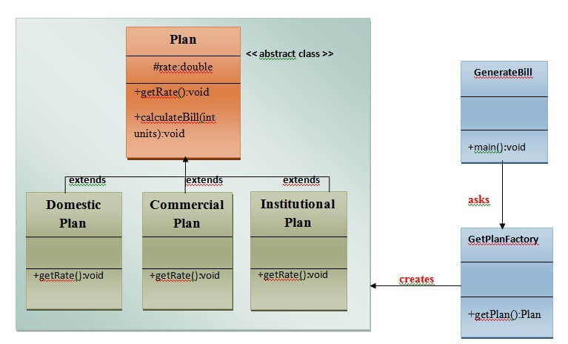

# Prototype Design Pattern

Prototype Pattern says that **cloning of an existing object instead of creating new one and can also be customized as per the requirement**.

This pattern should be followed, if the cost of creating a new object is expensive and resource intensive.

**(Behavioural)Observer Design** <https://www.youtube.com/watch?v=wiQdrH2YpT4>

An Observer Pattern says that "just define a one-to-one dependency so that when one object changes state, all its dependents are notified and updated automatically".

The Memento pattern is also known as Dependents or Publish-Subscribe.

**Example Flipkart TV purchase -> Not avaible -> notification when available**

## Benefits:

* It describes the coupling between the objects and the observer.
* It provides the support for broadcast-type communication.

